 Melissa Meline

Ch 6 Tutorial

**Tutorial 6-1** pages 345 – 348

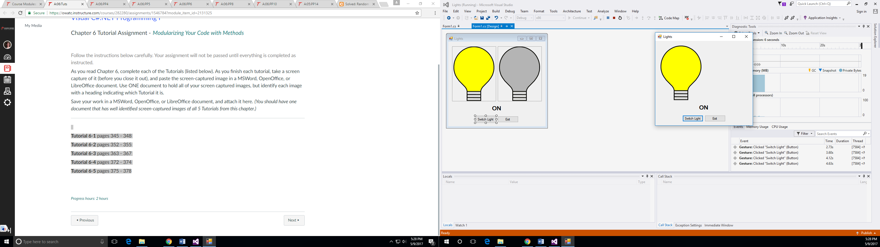

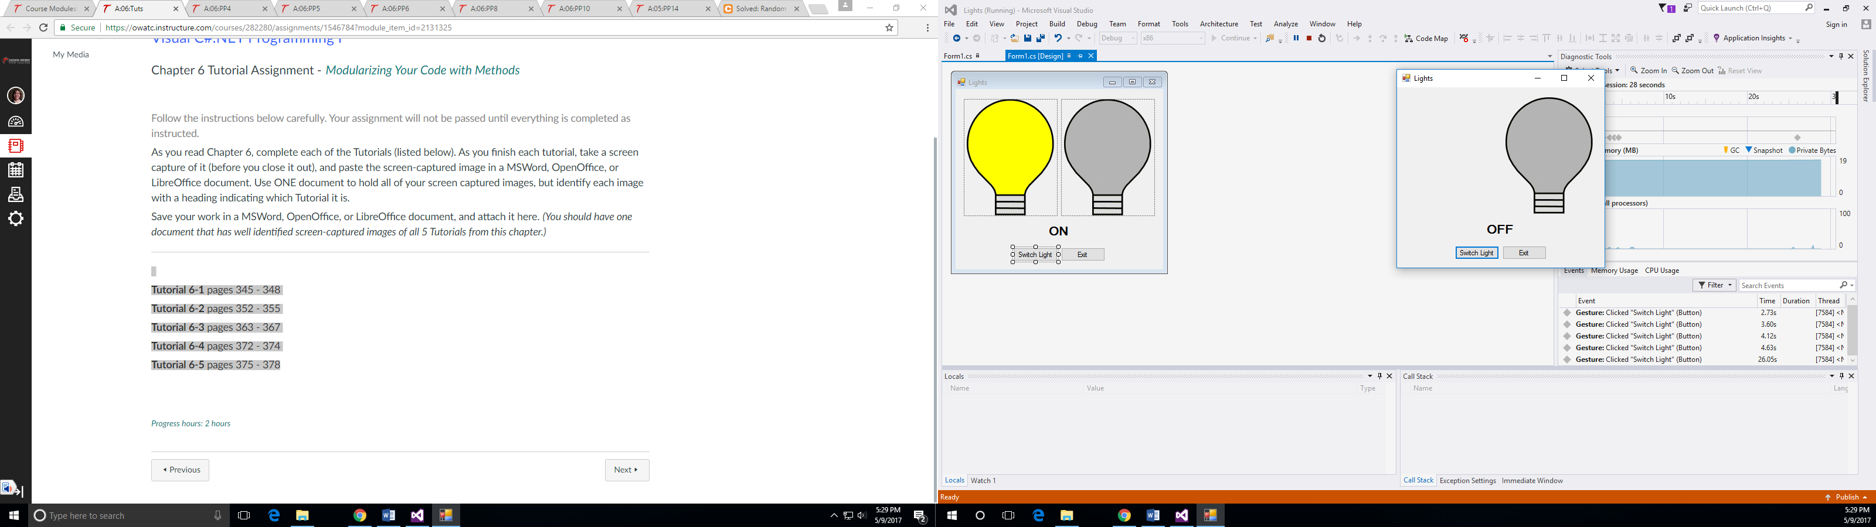

**Tutorial 6-2** pages 352 – 355

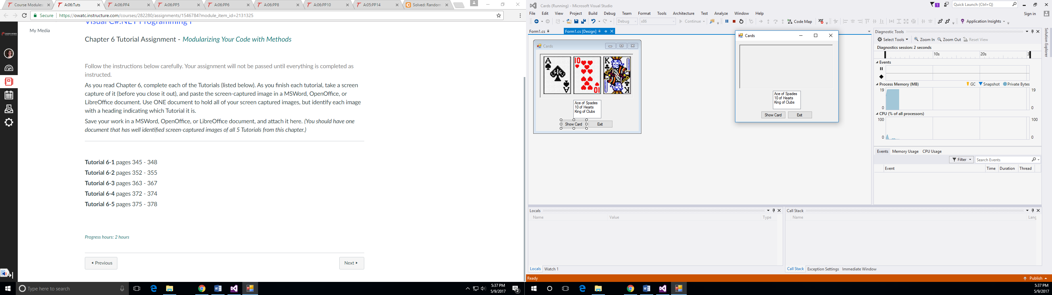

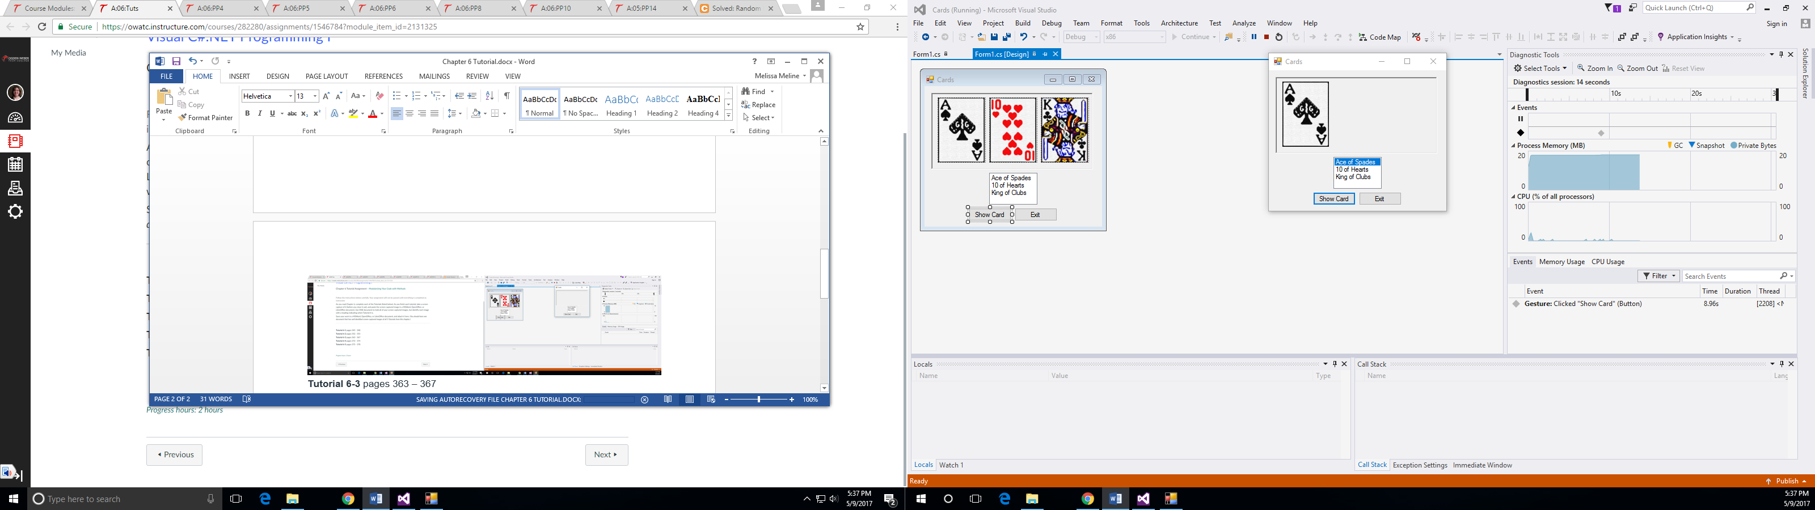

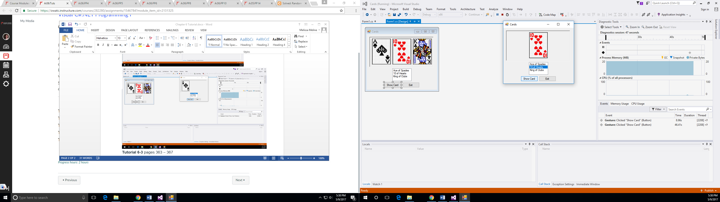

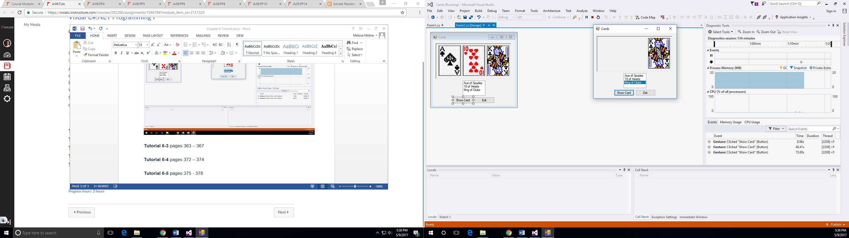

**Tutorial 6-3** pages 363 – 367

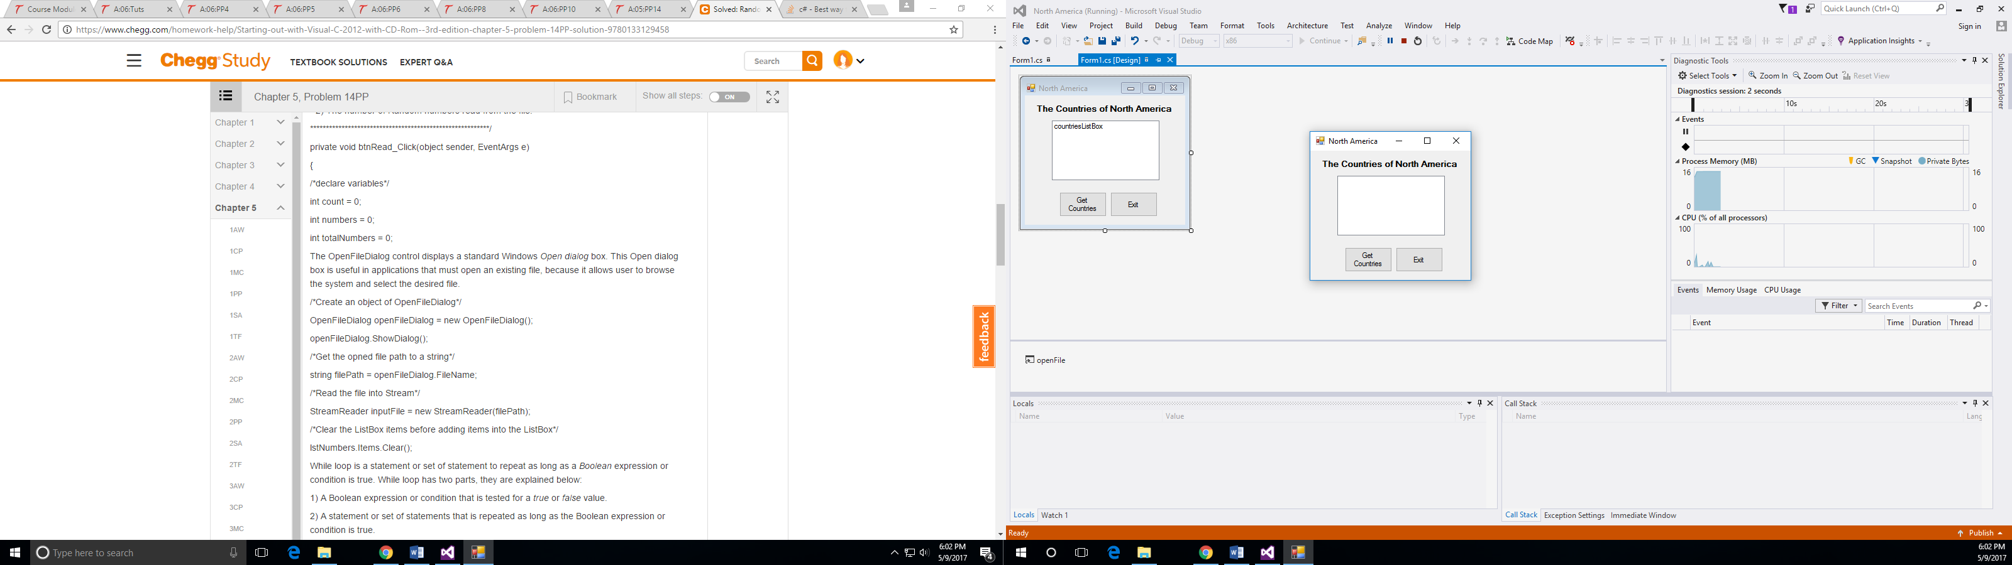

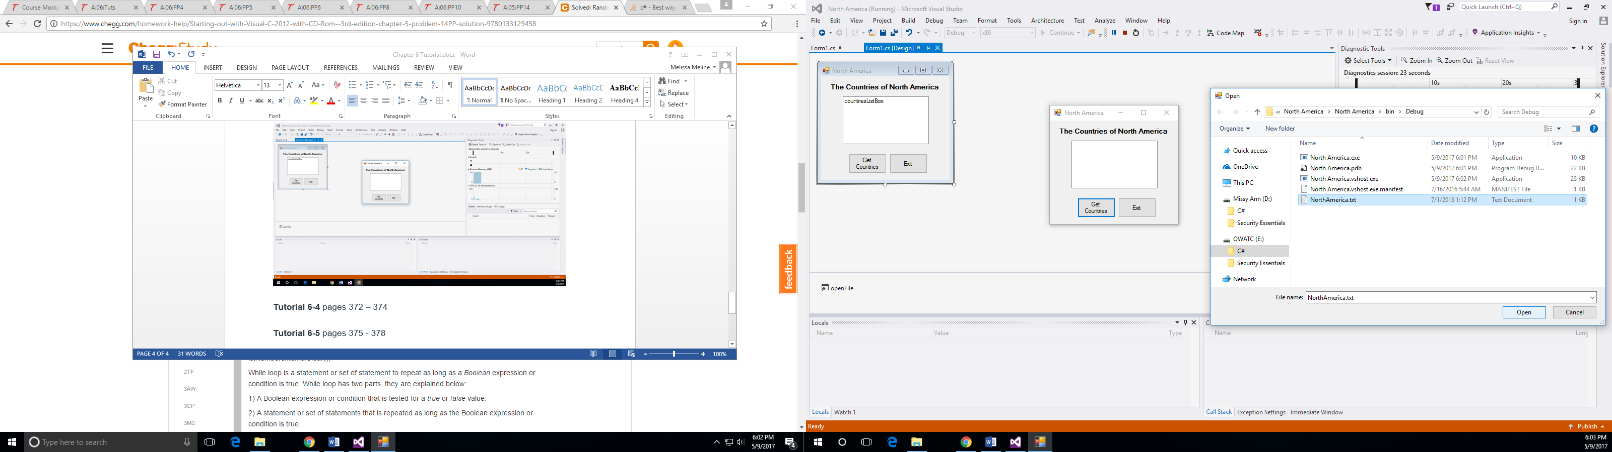

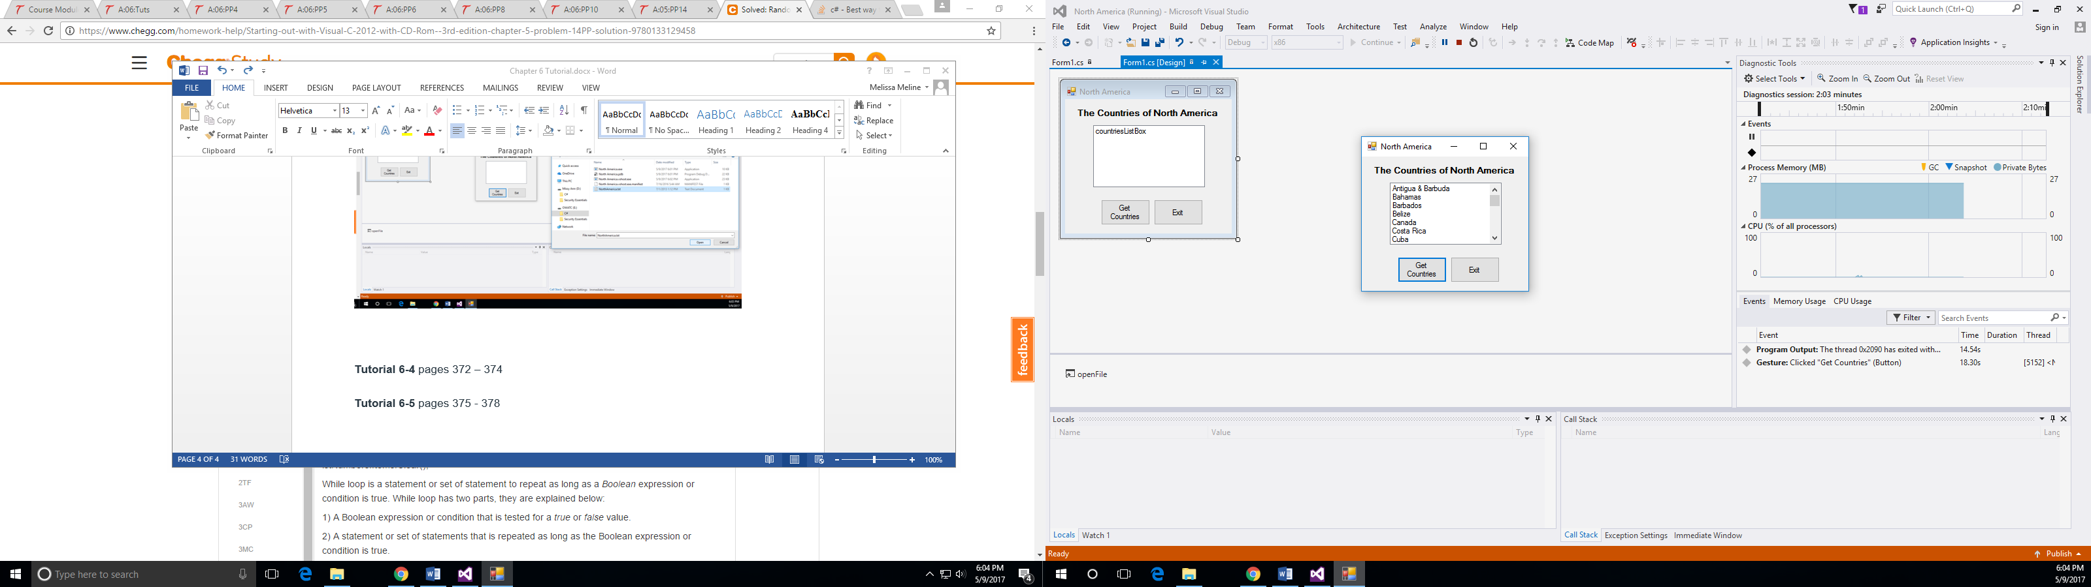

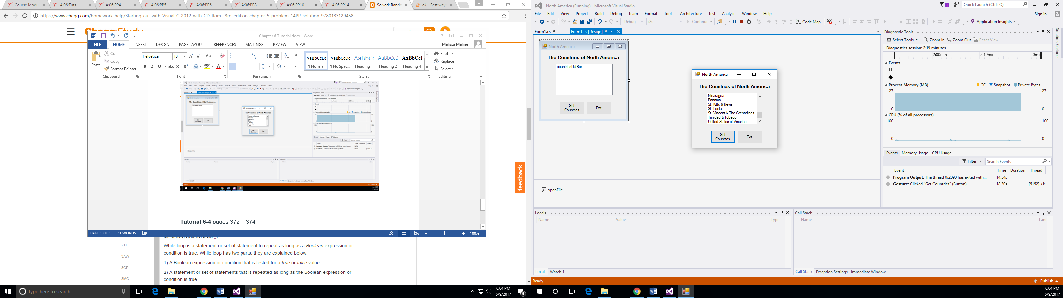

**Tutorial 6-4** pages 372 – 374

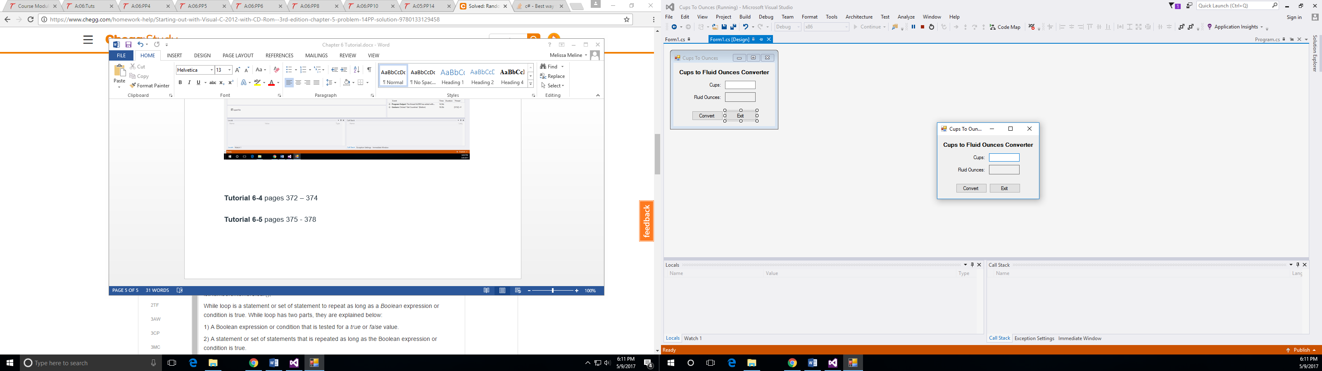

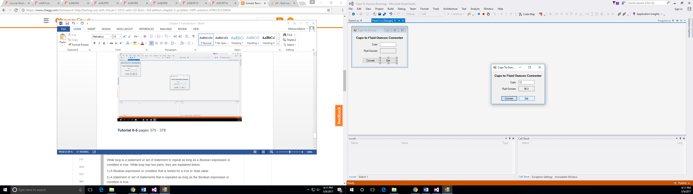

**Tutorial 6-5** pages 375 - 378

